Using Zoom in Jacobs 110, 112, 122
- Open the Zoom app on the teaching station PC, and select “Sign in with SSO” on the right hand side.
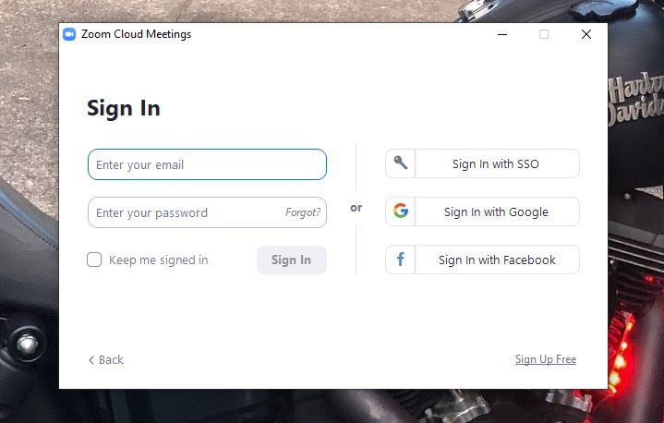

- Enter ‘buffalo’ as the domain and click continue.
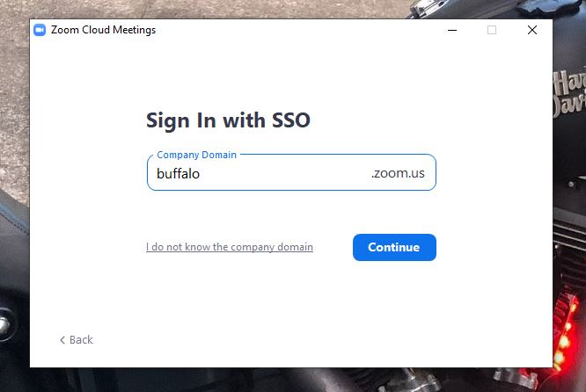

- You will be taken to the UB sign on screen, login with your UBIT name and password.

NOTE: BE SURE TO LOGOUT AT THE END OF YOUR CLASS

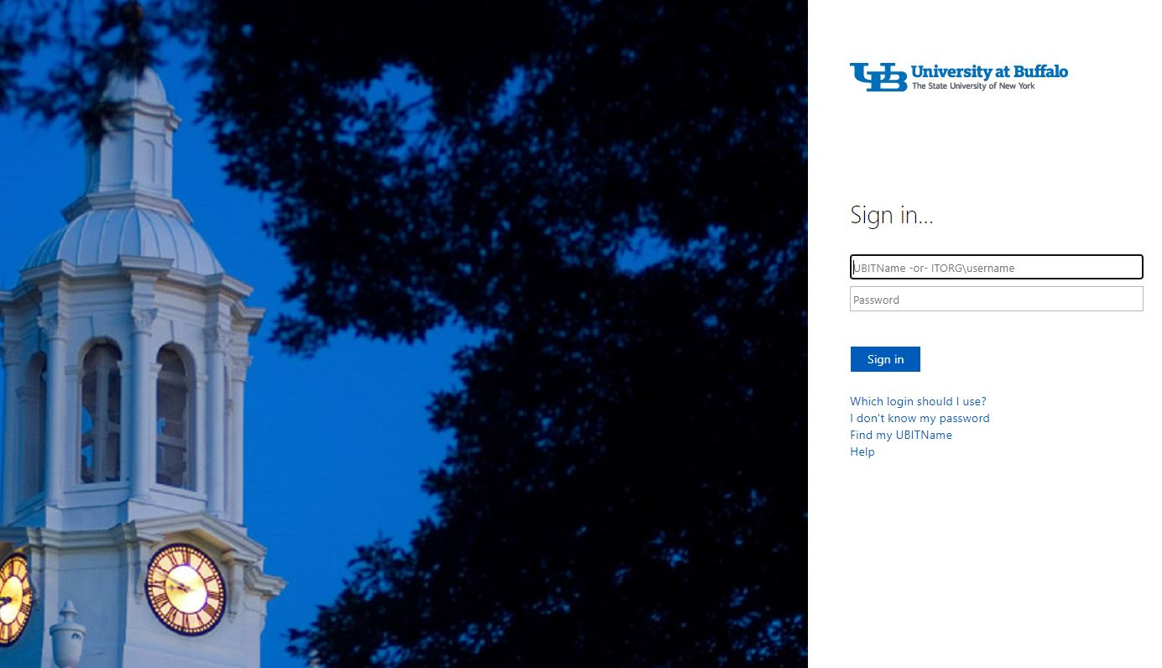

- A Zoom page will open, and a box will appear with an option to open Zoom. That will open the desktop app.
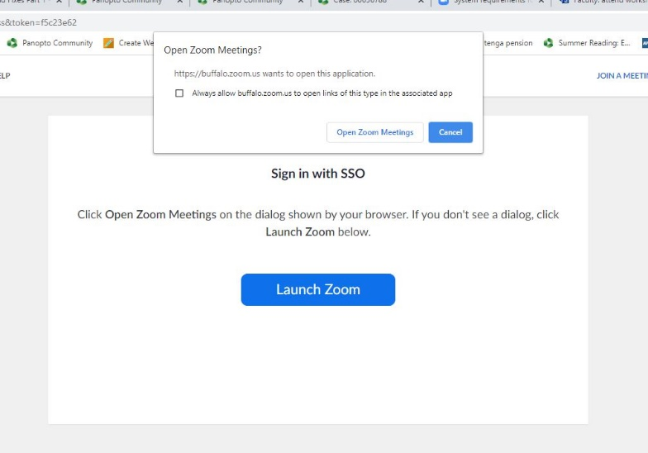

- Start your meeting, either from the Zoom web portal (buffalo.zoom.us), the desktop app, or UB Learns if using the Zoom integration.

- Select your video and audio, and choose the speaker source to hear students on the far end.

The microphone and speaker are both under the Audio button, the Camera is listed under the video button.
Turn on the gooseneck microphone on the top of the podium.

For Microphone select the option that includes the words “AV Bridge”. If you’re bringing a personal USB microphone that you want to use, select that device.

For Camera, select the option with the words “AV Bridge”.

For speaker, select the option that includes the word “Crestron”.

- The document camera is available as a source to share in Zoom in the 110, 112, and 122. To select the doc cam, press the Screen Share button, select Advanced at the top, then press the button for “Content from 2nd Camera, and hit “Share”.

NOTE: PLEASE POWER ON AND SETUP THE DOCUMENT CAMERA BEFORE YOUR CLASS STARTS TO MAKE SURE IT’S SETUP PROPERLY
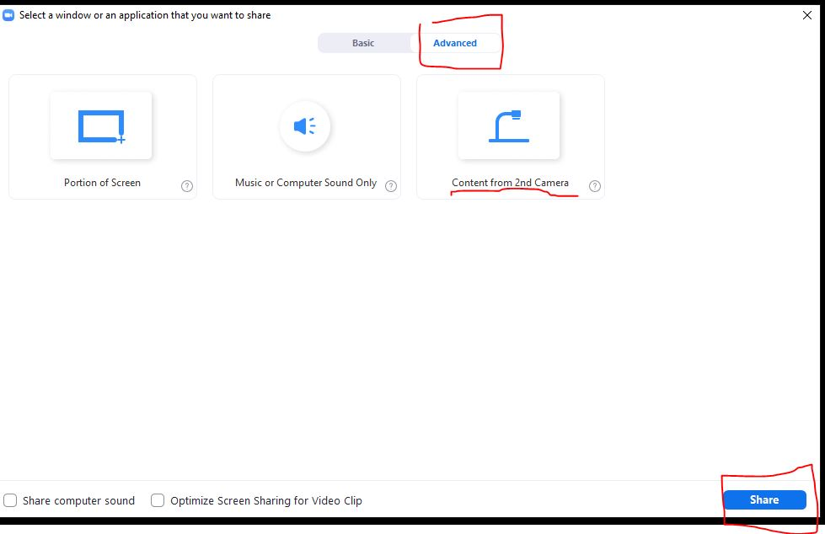

- If you need to play an audio file ONLY from the PC, click the Share Screen button, click “Advanced” across the top, and then press “Computer Audio.” You have the option to select Mono or Stereo audio. Hit Share.
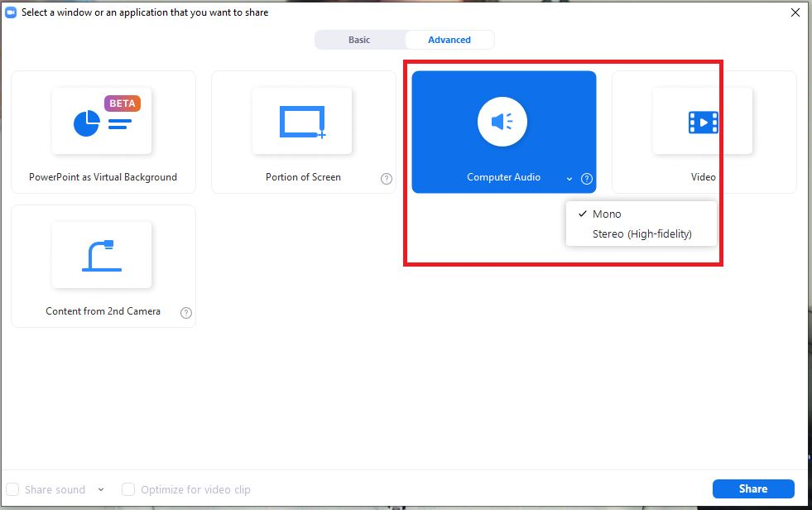

- If you are playing a video clip off a website, click the “Share Screen” button, select the app or screen you want to share, and then check “Share Computer Sound” and “Optimize Screen Sharing for Video Clip” in the lower left. Hit “Share”.
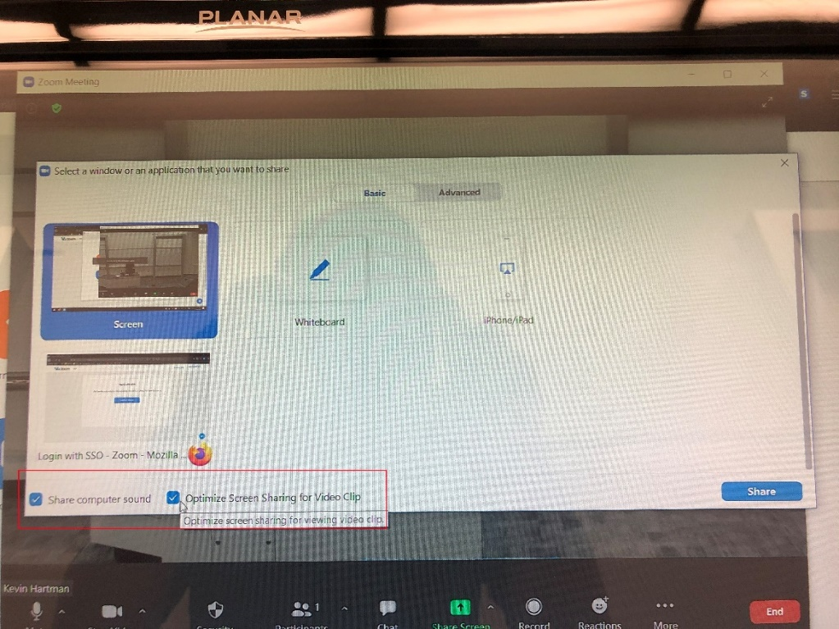
- If you need to play a video file from the PC, click the Share Screen button, click “Advanced” across the top, and then press “Video.” Hit Share. A dialog box will open and you can select the video for playback. Once the video is open, you can playback the recording.
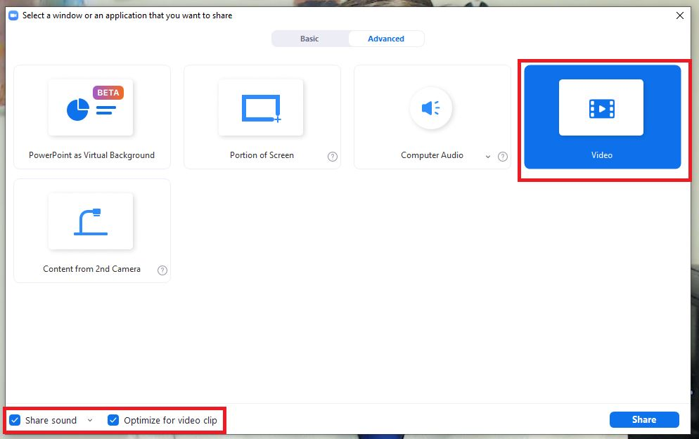
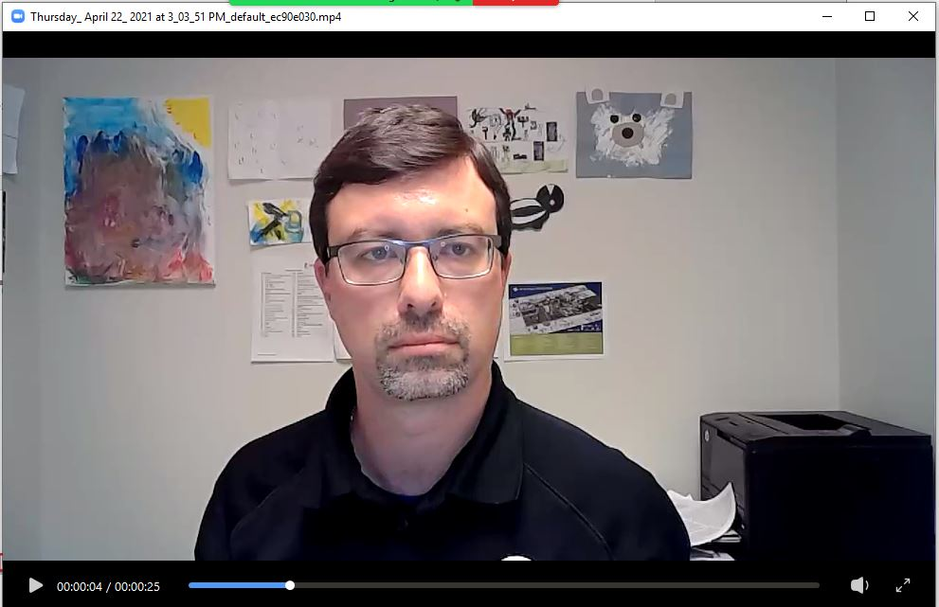

- When your class is over, end the Zoom meeting, and sign out and close out of Zoom and other services you opened (UB Learns, UB Box, etc.)

