Setting up your email signature

Choose an option below, customize it with your own contact information and then go to page 2 to set up.

Note: you may not modify spacing in any way.

Option 1

_ _ _ _ _ _ _ _ _ _ _ _ _ _ _ _ _ _
Fname Lname
Title
Department (Optional but use full name, no &)
School of Management
University at Buffalo
XXX Jacobs Management Center (or XX Alfiero Center)
Buffalo, NY 14260-4000
Tel.: 716-645-XXXX
Cell: xxx-xxx-xxxx (optional)
Fax: xxx-xxx-xxxx (optional)
Pronouns: he/him/his or she/her/hers or they/them/their (optional)
Facebook | Twitter | LinkedIn | Instagram

Tips and Guidelines:
- You must use the complete signature from the dotted line (included) to the images at bottom. You may not add any other images from other organizations or change the spacing.
- Department is often in title, therefore not needed in most cases
  - Professor of Management Science and Systems
  - Director of Communications
  - Academic Advisor, Undergraduate Programs
- Fax is rarely needed anymore
- Keep font and font size exactly as it is.
- Keep the logo exactly as it is. Do not resize, change or substitute the logo in any way.
- Do not modify the distance of the logo from the copy block.
- Avoiding adding anything else to your work signature such as quotes or photos

FOR OPTIMAL RESOLUTION, SEE PAGE 3 AND 4 FOR DIRECTIONS TO LOAD INTO OUTLOOK

Option 2 (with SUNY Modifier – available to all, but recommended especially for anyone working with an international audience)

Note: you may not modify spacing in any way.

_ _ _ _ _ _ _ _ _ _ _ _ _ _ _ _ _ _
Fname Lname
Title
Department (Optional but use full name, no &)
School of Management
University at Buffalo, The State University of New York
XXX Jacobs Management Center (or xx Alfiero Center)
Buffalo, NY 14260-4000
Tel.: 716-645-XXXX
Cell: xxx-xxx-xxxx (optional)
Fax: xxx-xxx-xxxx (optional)
Pronouns: he/him/his or she/her/hers or they/them/their (optional)
Facebook | Twitter | LinkedIn | Instagram

Tips and Guidelines:
- You must use the complete signature from the dotted line (included) to the images at bottom. You may not add any other images from other organizations or change the spacing.
- Department is often in title, therefore not needed in most cases
  - Professor of Management Science and Systems
  - Director of Communications
  - Academic Advisor, Undergraduate Programs
- Fax is rarely needed anymore
- Keep font and font size exactly as it is.
- Keep the logo exactly as it is. Do not resize, change or substitute the logo in any way.
- Do not modify the distance of the logo from the copy block.
- Avoiding adding anything else to your work signature such as quotes or photos

FOR OPTIMAL RESOLUTION, SEE PAGE 3 AND 4 FOR DIRECTIONS TO LOAD INTO OUTLOOK
Open a new email message.
- On the Message menu, select Signature > Signatures.
Depending on the size of your Outlook window and whether you're composing a new email message or a reply or forward, the Message menu and the Signature button might be in different locations.
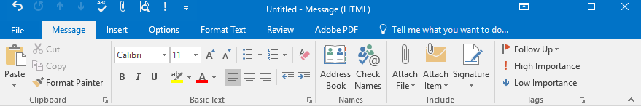
- Under Select signature to edit, choose New, and in the New Signature dialog box, type a name for the signature, such as Work Signature.
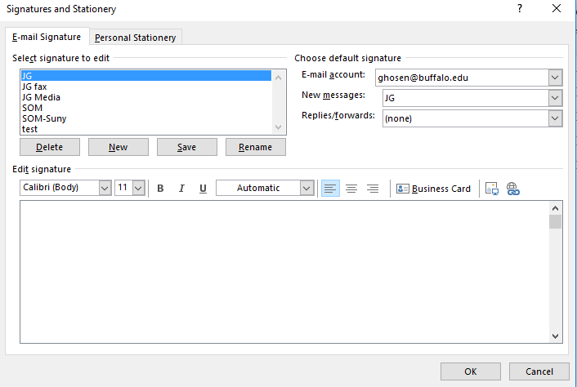

- Under Edit signature, paste your signature (customized from Option 1 or Option 2 on page 1 of this document). Be sure to keep source formatting, including logo/lockup, and click SAVE.
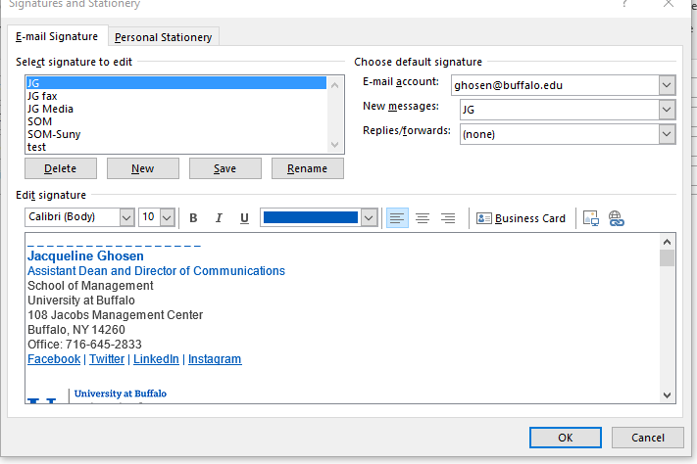

- Under Choose default signature, set the following options for your signature:
- In the E-mail account drop-down box, choose an email account to associate with the signature. You can have different signatures for each email account.
- If you want your signature added to all new messages by default, in the New messages drop-down box, select one of your signatures. If you don't want to automatically add a signature to new messages, choose (none). This doesn't add a signature to any messages you reply to or forward.
- If you want your signature to appear in the messages you reply to and forward, in the Replies/forwards drop-down, select one of your signatures. Otherwise, accept the default option of (none).
- Choose OK to save your new signature and return to your message. Outlook doesn't add your new signature to the message you opened in Step 1, even if you chose to apply the signature to all new messages. You'll have to add the signature manually to this one message. All future messages will have the signature added automatically. To add the signature manually, select Signature from the Message menu and then pick the signature you just created.

