# Your School of Management email signature

Choose an option below and copy/paste (with links to our website and social media) into your signature setup box in your email.

Anything in (parentheses) is instructional. Delete after reviewing.

## Option 1 – Without SUNY modifier

**_ _ _ _ _ _ _ _ _ _ _ _ _ _ _ _ _ _** (Include this dotted line)

**Victor E. Bull, PhD** (*he/him*) (Degree optional, pronouns optional, but encouraged for inclusivity)

Clinical Assistant Professor of Organization and Human Resources

Department (Department optional, but not needed when part of title as above. If used, spell out with no ampersands)

School of Management

University at Buffalo

XXX Jacobs Management Center (or XX Alfiero Center)

Buffalo, NY 14260-4000 (or 14260-4010 if in Alfiero Center)

Office: 716-645-XXXX | Cell: 716-645-XXXX | Fax: 716-645-XXXX (cell optional, fax rarely needed)

[management.buffalo.edu](https://management.buffalo.edu) (Keep the hyperlinks)

[Facebook](https://www.facebook.com/UBSchoolOfMgt/) | [X/Twitter](https://x.com/UBSchoolofMGT) | [LinkedIn](https://www.linkedin.com/school/ubschoolofmgt/) | [Instagram](https://www.instagram.com/ubschoolofmgt/) (Keep the hyperlinks)

Option 2 – With SUNY modifier  
Available to all, but recommended especially for anyone working with an international audience

**_ _ _ _ _ _ _ _ _ _ _ _ _ _ _ _ _ _** (Include this dotted line)

**Victor E. Bull, PhD (***he/him***)** (Degree optional,pronouns optional, but encouraged for inclusivity)

Clinical Assistant Professor of Organization and Human Resources

Department (Department optional, but not needed when part of title as above. If used, spell out, no ampersands)

School of Management

University at Buffalo, The State University of New York

XXX Jacobs Management Center (or XX Alfiero Center)

Buffalo, NY 14260-4000 (or 14260-4010 if in Alfiero Center)

Office: 716-645-XXXX | Cell: 716-645-XXXX | Fax: 716-645-XXXX (cell optional, fax rarely needed)

[management.buffalo.edu](https://management.buffalo.edu) (Keep the hyperlinks)

[Facebook](https://www.facebook.com/UBSchoolOfMgt/) | [X/Twitter](https://x.com/UBSchoolofMGT) | [LinkedIn](https://www.linkedin.com/school/ubschoolofmgt/) | [Instagram](https://www.instagram.com/ubschoolofmgt/) (Keep the hyperlinks)

**Note: These are approved UB fonts. Do not modify fonts, font size or spacing.**

Although all components are included in the examples above. Some are optional: pronouns (*she/her; he/him, they/them*) are encouraged to promote an inclusive environment, fax is usually not needed, and degrees and cell number are at your discretion.

If you cut and paste the signatures above, colors will render accurately in RICH text or HTML format. If you ceate from scratch, use the following color code for UB Blue: RGB: 0, 91, 187, and use the following grey for the rest of the text: RGB: 64, 64, 64. If using plain text format, colors will not render.

**To set up your signature in Outlook on your PC, see following pages of this document.**

**To set up your signature in Outlook on your Mac, visit the** [**Microsoft instructions**](https://support.microsoft.com/en-us/office/change-or-update-an-email-signature-in-outlook-for-mac-d302cc7d-a269-4e3e-b3f1-5fc12e7d17a9)**.**

## Setting up your signature in Outlook

1. Open a new email message.
2. On the **Message** menu, select **Signature** > **Signatures**.
3. Depending on the size of your Outlook window and whether you're composing a new email message or a reply or forward, the **Message** menu and the **Signature** button might be in different locations.  
     
   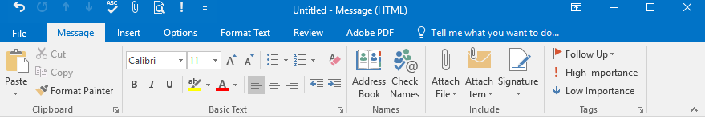
4. Under **Select signature to edit**, choose **New**, and in the **New Signature** dialog box, type a *name* for the signature, such as Work Signature.

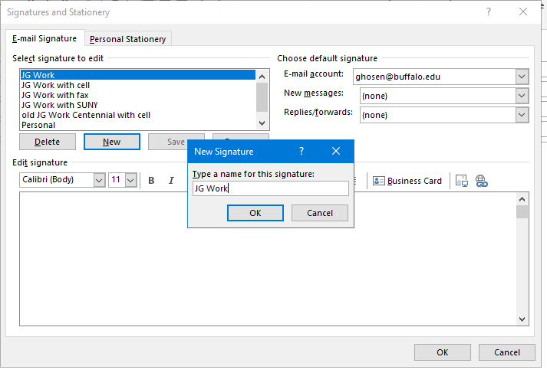

1. Under **Edit signature**, paste your signature (customized from Option 1 or Option 2 on page 1 of this document). Be sure to keep source formatting, including hyperlinks, and click SAVE.

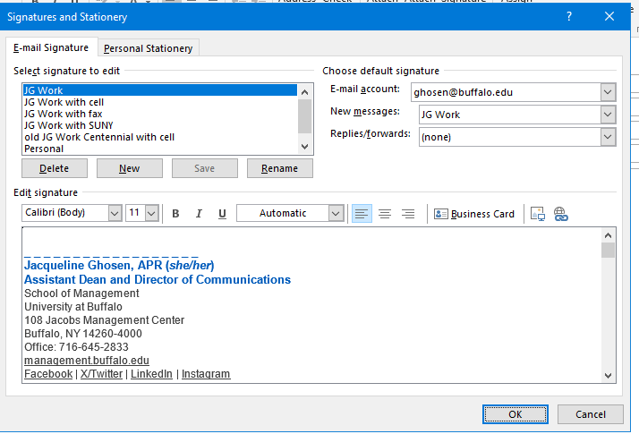

1. Under **Choose default signature**, set the following options for your signature:

* In the **E-mail account** drop-down box, choose an email account to associate with the signature. You can have different signatures for each email account.
* If you wish to add your signature to all new messages by default, in the **New messages** drop-down box, select one of your signatures. If you don't wish to automatically add a signature to new messages, choose (none).
* If you wish to have your signature appear in the messages you reply to and forward, in the **Replies/forwards** drop-down, select one of your signatures. Otherwise, accept the default option of (none).

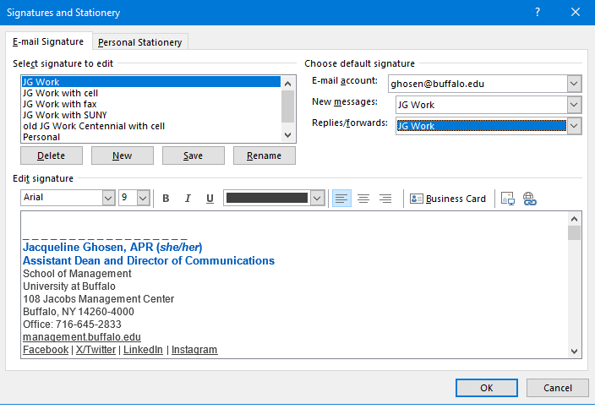

1. Choose **OK** to save your new signature and return to your message. Outlook doesn't add your new signature to the message you opened in Step 1, even if you chose to apply the signature to all new messages.

You'll have to add the signature manually to this one message. All future messages will have the signature added automatically. To add the signature manually, select **Signature** from the **Message** menu and then pick the signature you just created.

