Using Panopto in Jacobs B32

- On the teaching station computer, https://ub.hosted.panopto.com/ Click the Sign in button in the upper right, click the sign in button again, and then sign in using your UBIT name and password.
NOTE: BE SURE TO LOGOUT AT THE END OF YOUR CLASS

- Once in the cloud, press the blue Create button at the top, and select the first option, “Record a New Session”. This will open the software. NOTE: On some web browsers, you may be asked to open the software first.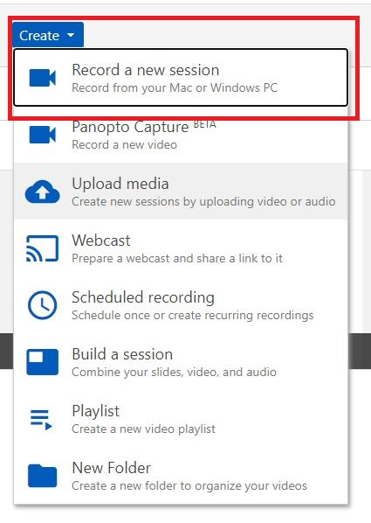

- When the software opens, at the top, select the course folder you want to record to from the drop down and give the recording a title. You also have the option to check the box to live webcast your recording.

NOTE: While you can record to your “My Folder” folder, by default recordings stored there are private only to you, so students cannot see recordings there unless you move them to a course folder or change the settings on that video.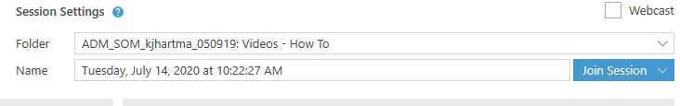

- On the left hand side of the recording software, you can pick your Primary Sources.
For camera, choose “HD Pro Webcam C920” if not already selected.
For Audio, select “Microphone (HD Pro Webcam C920)”. The video selection is optional, the audio selection is REQUIRED, you won’t be able to make a recording otherwise.
Do a quick mic check and adjust your audio level accordingly by sliding the blue ball.

Audio levels in green and yellow are good, levels in red are clipping or distorted, and make your audio unusable. You can also click “Capture Computer Audio” if you are playing an audio file you need captured on the recording (Ex. A YouTube video, .mp3 audio file)
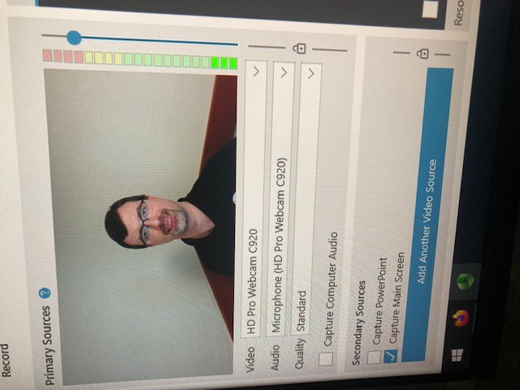

- Secondary Sources: You can choose to Capture PowerPoint (only PPT) and Capture Main Screen (captures everything you do on screen)
NOTE: If you choose to live webcast and/or like to annotate over PowerPoint slides, you MUST choose Capture Main Screen. “Capture PowerPoint” basically takes a picture of each slide, it doesn’t capture animations/transitions between slides, links to webpages you may open from a slide, nor annotating.
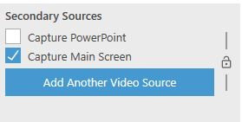

In Jacobs B32 you can also capture the document camera if you want. To do so, press the “Add Another Video Source” button, and select the “Wolfvision” option in the dropdown box. Panopto will record both the computer screen and the document camera.

Please remember to audibly say in your recordings when you would like student to press the button to choose between viewing the screen content and viewing the document camera. Otherwise you will have to do editing to make sure students are viewing the correct content.

- In the bottom right you can also control your secondary source resolution. You should be able to do 1920 x 1080 resolution. In the Resolution dropdown box, choose 1920 x 1080 if not selected for you already.

Set FPS (frames per second) and kbps (Bit Rate). The highest you can go is 30 and 2500 respectively. Slide the blue circles for each option to the right as far as possible to get these numbers.

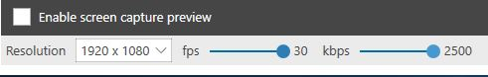

- When all sources and folders are properly selected, press the red circle Record button in the upper left. This will start your recording. You will see Pause and Stop buttons replace the Record button on the software if you are only recording, there will not be a Pause button if you are live webcasting. Stop the recording when you are done lecturing.
Keyboard Shortcuts:
- Record – F8
- Pause/Resume – F9
- Stop – F10

- After you stop recording, you’ll come to the Recording Complete screen where you can rename the recording and add an optional description here. Hit the Done button.
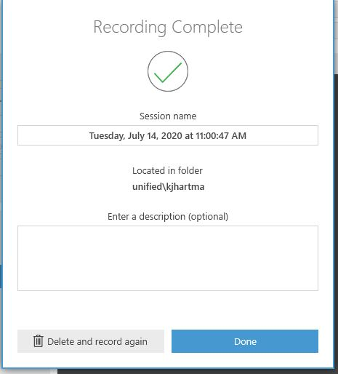

- Your recording will begin to upload and you can will the upload progress. When the recording has finished uploading, please press the “Delete Local” button to remove the proprietary files Panopto created on the podium computer.
DO NOT log out until the recording has uploaded completely. 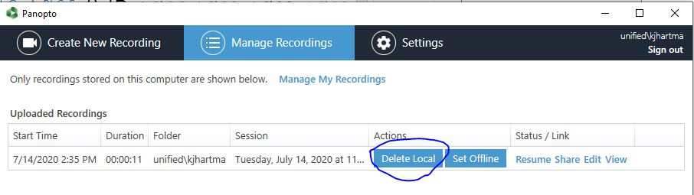
- Once your recording has uploaded completely, please sign out of the recording software by clicking the “Sign Out” button in the upper right of the program, and sign out of the webpage as well by clicking your name in the upper right and hitting the “Sign Out” button.
Please also remember to sign out of other applications if you opened them as well (Box, UB Learns, etc.)
