Using Panopto in Alfiero 205

NOTE: If you are already comfortable using Panopto, steps 1, 2, and 6 are specific to Alfiero 205.

- Power On Web Camera: When you enter 205, look for the camera remote control at the podium. It is the dark colored remote. The power button is in the upper left corner. You will need to walk up right in front of the cameras to turn them on.

The “Instructor” camera is on the wall near the clock and door. The “Audience” camera is near the podium. Turn on whichever one you need. When the cameras are powered off, the camera and the lens will be facing the wall. When it’s turned on, a green light will appear and the lens faces away from the wall.
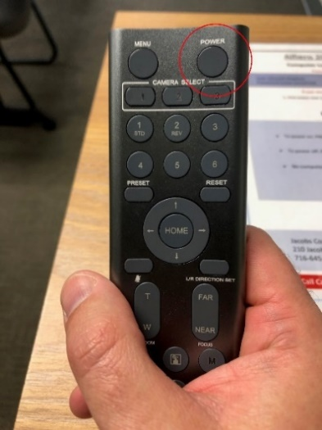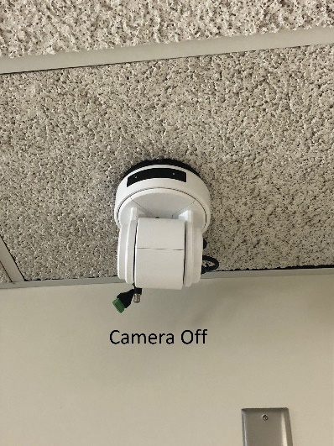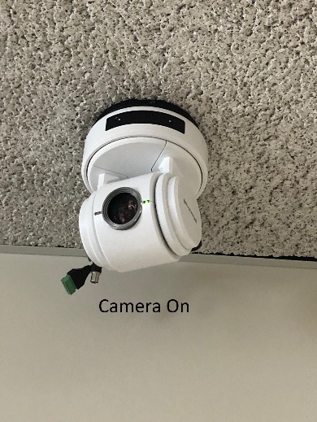

- Power On Ceiling Projector: The other remote at the podium is for the projector. Press the green On button in the top right to turn it on. Note: For audio playback in the room of a file from the computer or to hear guests on the far end of the Zoom call, you will need to have the projector turned on.
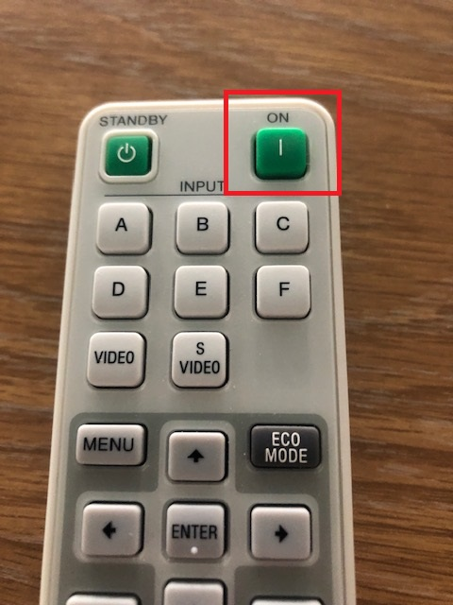

- Login to Panopto: At the podium computer, navigate to https://ub.hosted.panopto.com/ in a web browser. Click the Sign in button in the upper right, click the sign in button again, and then sign in using your UBIT name and password.
NOTE: BE SURE TO LOGOUT AT THE END OF YOUR CLASS

- Once in the cloud, press the blue Create button at the top, and select the first option, “Record a New Session”. This will open the software, though on some web browsers, a dialog box will pop up asking you to open the software first.
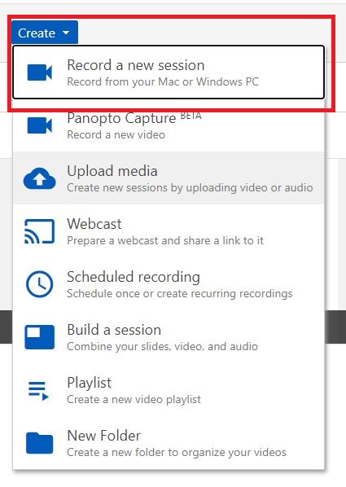

- When the software opens, at the top, select the course folder you want to record to from the drop down and give the recording a title. You also have the option to check the box to live webcast your recording.

NOTE: While you can record to your “My Folder” folder, by default recordings stored there are private only to you, so students cannot see recordings there unless you move them to a course folder or change the settings on that video.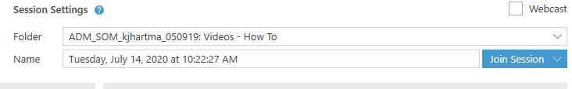

- Select Camera & Microphone: On the left hand side of the recording software, select your camera and sources under the Primary Sources section.
If you want to record the Teacher Camera, in the video drop down menu, choose the 2nd listing of MEI CV610-U3-V2.
If you want to record the Teacher Microphone, in the audio drop down menu, choose “Digital Audio Interface (2 – MEI CV610-U3-V2)”.
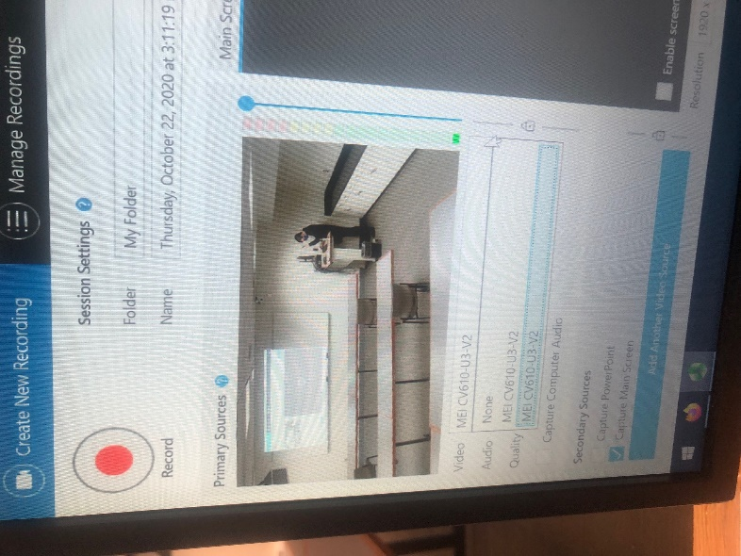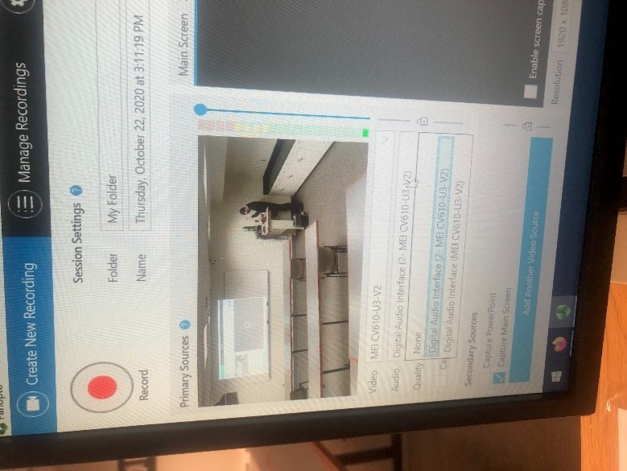

If you want to record the Audience Camera, in the video drop down menu, choose the first listing of MEI CV610-U3-V2. If you bring your own USB webcam and plug that into the PC, you will have the option to choose that.
For the Audience Microphone, in the audio drop down menu, choose “Digital Audio Interface (MEI CV610-U3-V2)”. If you bring your own USB webcam and plug that into the PC, you will have the option to choose that.
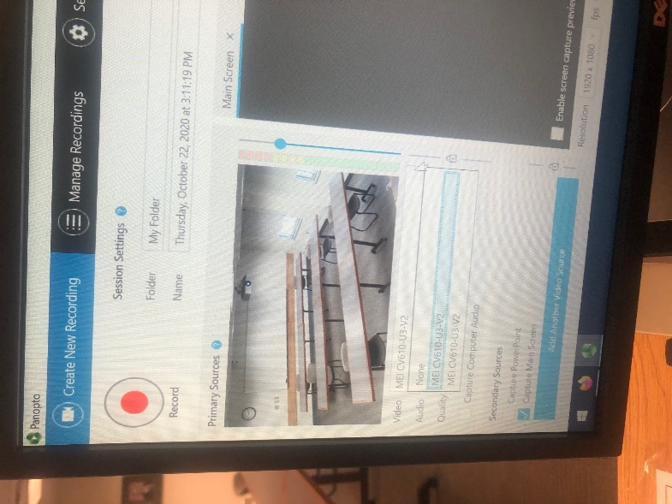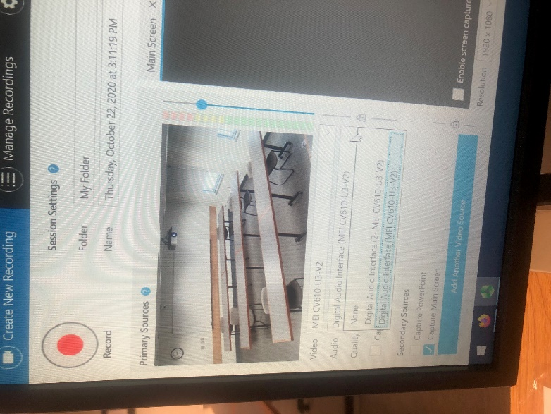
The video selection and audio selections are REQUIRED, you won’t be able to make a recording otherwise.
NOTE: The microphones are integrated into the camera. You cannot select the Audience Mic and Instructor Camera, or vice versa. If you want to use a personal USB webcam and microphone, please contact SOM-IT.
Do a quick mic check and adjust your audio level accordingly by sliding the blue ball. The microphones themselves are in the ceiling: The teacher mic is near the projected image and podium, the audience mic is in the ceiling near the projector.
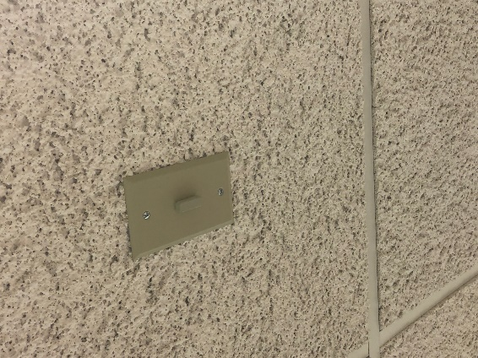

Audio levels in green and yellow are good, levels in red are clipping or distorted, and make your audio unusable. You can also click “Capture Computer Audio” if you are playing an audio file you need captured on the recording (Ex. A YouTube video, .mp3 audio file)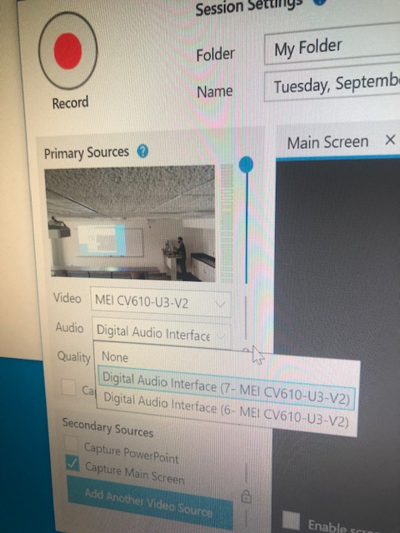

- Secondary Sources: You can choose to Capture PowerPoint (only PPT) and Capture Main Screen (captures everything you do on screen)
NOTE: If you choose to live webcast and/or like to annotate over PowerPoint slides, you MUST choose Capture Main Screen. “Capture PowerPoint” basically takes a picture of each slide, it doesn’t capture animations/transitions between slides, links to webpages you may open from a slide, nor annotating.
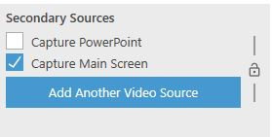

- In the bottom right you can also control your secondary source resolution. You should be able to do 1920 x 1080 resolution. In the Resolution dropdown box, choose 1920 x 1080 if not selected for you already.

Set FPS (frames per second) and kbps (Bit Rate). The highest you can go is 30 and 2500 respectively. Slide the blue circles for each option to the right as far as possible to get these numbers.

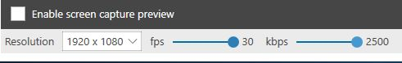

- When all sources and folders are properly selected, press the red circle Record button in the upper left. This will start your recording. You will see Pause and Stop buttons replace the Record button on the software if you are only recording, there will not be a Pause button if you are live webcasting. Stop the recording when you are done lecturing.
Keyboard Shortcuts:
- Record – F8
- Pause/Resume – F9
- Stop – F10

- After you stop recording, you’ll come to the Recording Complete screen where you can rename the recording and add an optional description here. Hit the Done button.
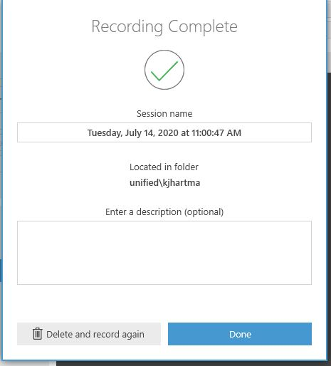

- Your recording will begin to upload and you can will the upload progress. When the recording has finished uploading, please press the “Delete Local” button to remove the proprietary files Panopto created on the podium computer.
DO NOT log out until the recording has uploaded completely. 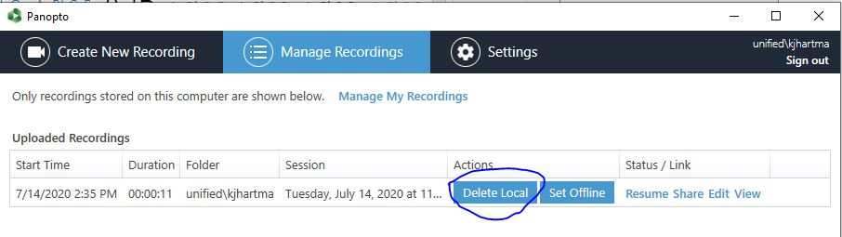
- Once your recording has uploaded completely, please sign out of the recording software by clicking the “Sign Out” button in the upper right of the program, and sign out of the webpage as well by clicking your name in the upper right and hitting the “Sign Out” button.
Please also remember to sign out of other applications if you opened them as well (Box, UB Learns, etc.)
