Using Zoom in Alfiero 205
NOTE: If you are already comfortable using Zoom, steps 1, 2, 7, and 8 are specific to Alfiero 205.

- Power On Web Camera: When you enter 205, look for the camera remote control at the podium. It is the dark colored remote. The power button is in the upper left corner. You will need to walk up right in front of the cameras to turn them on.

The “Instructor” camera is on the wall near the clock and door. The “Audience” camera is near the podium. Turn on whichever one, or both, you need. When the cameras are powered off, there will be an amber light on the front of the camera and the lens will be facing the wall. When it’s turned on, the light is green and the lens faces away from the wall.

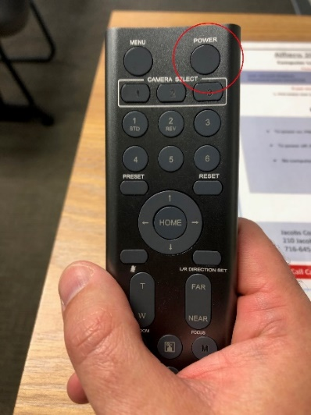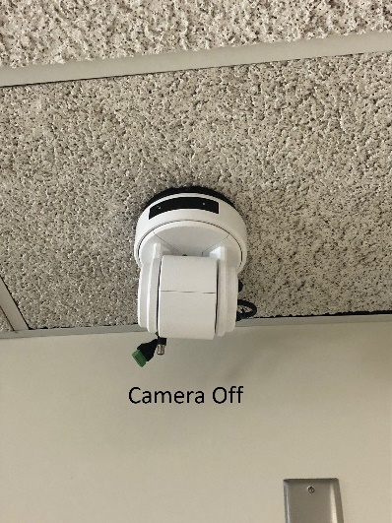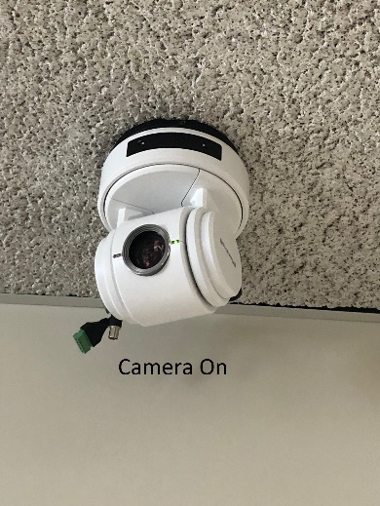

- Power On Ceiling Projector: The other remote at the podium is for the projector. Press the green On button in the top right to turn it on. Note: For audio playback in the room of a file from the computer or to hear guests on the far end of the Zoom call, you will need to have the projector turned on.
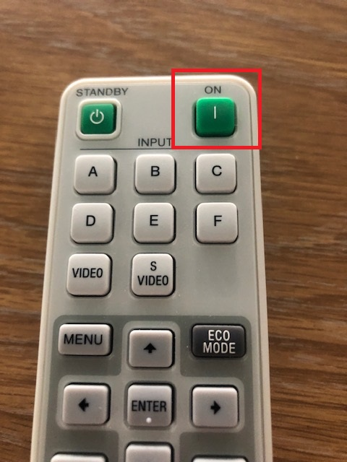

- Login to Zoom: Open the Zoom app on the teaching station PC, and select “Sign in with SSO” on the right hand side.
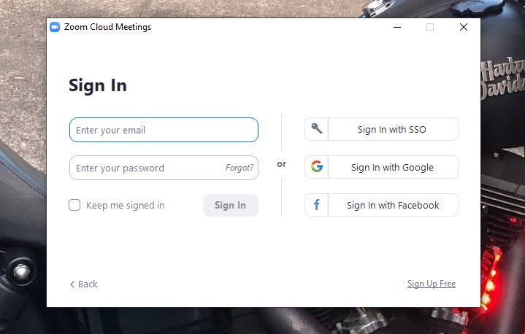

- Enter ‘buffalo’ as the domain and click continue.
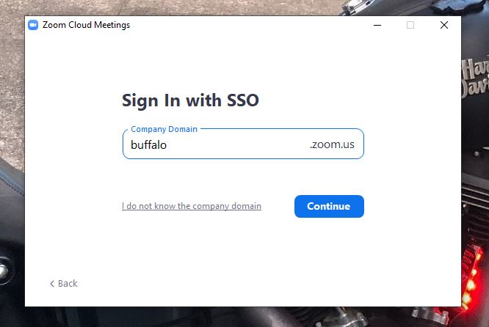

You will be taken to the UB sign on screen, login with your UBIT name and password.
NOTE: BE SURE TO LOGOUT AT THE END OF YOUR CLASS

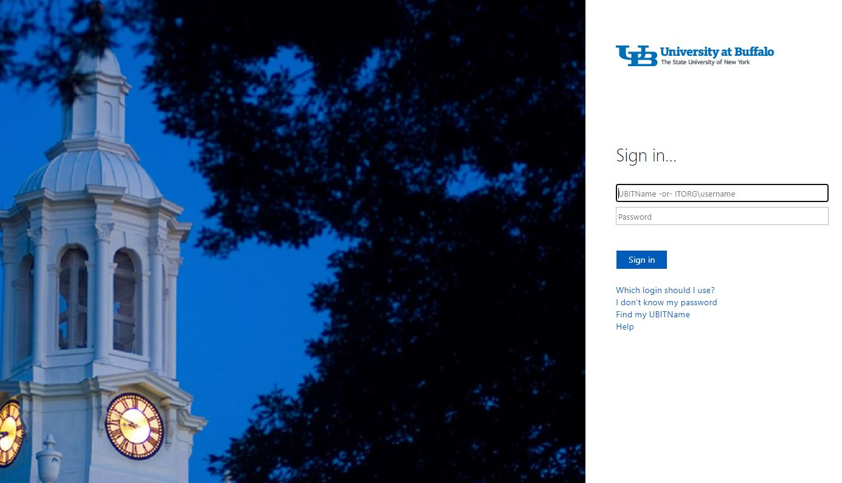

- A Zoom page will open, and a box will appear with an option to open Zoom. That will open the desktop app.
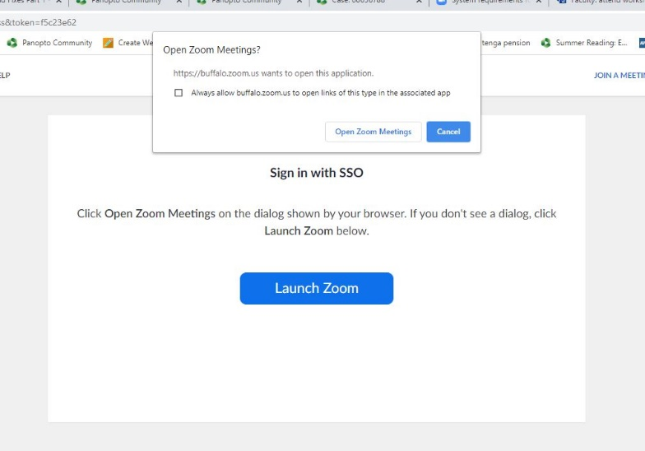

- Start your meeting, either from the Zoom web portal (buffalo.zoom.us), the desktop app, or UB Learns if using the Zoom integration.

- Select Your Microphone & Speaker: Select your video and audio, and choose the speaker source to hear students on the far end.

The microphone and speaker are both under the Audio button, the Camera is listed under the video button.

If using the Instructor Camera, press the audio button and under Microphone select “Digital Audio Interface (2 – MEI CV610-U3-V2)”
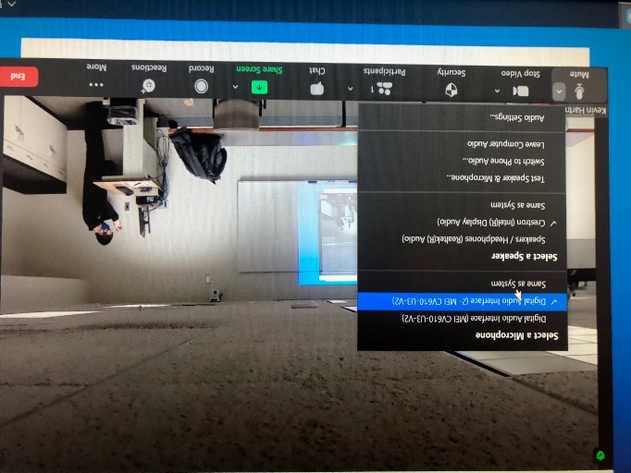

If using the Audience Camera, press the audio button and under Microphone select “Digital Audio Interface (MEI CV610-U3-V2)”
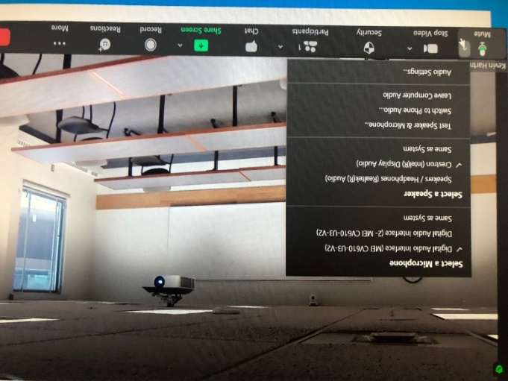
For speaker for both, select Crestron (Intel Display Audio).

- Select Your Camera: For Instructor Camera, under the video button, select the 2nd listed option for “MEI CV610-U3-V2”.
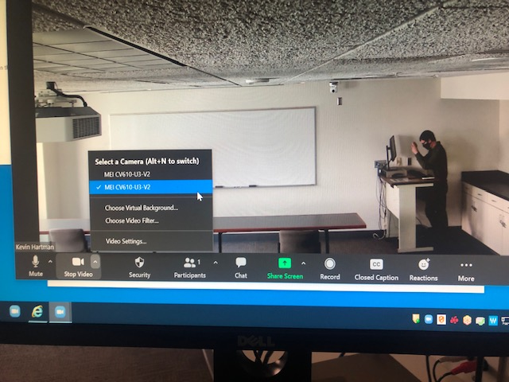

For Audience Camera, under the video button, select the 1st listed option for “MEI CV610-U3-V2”.

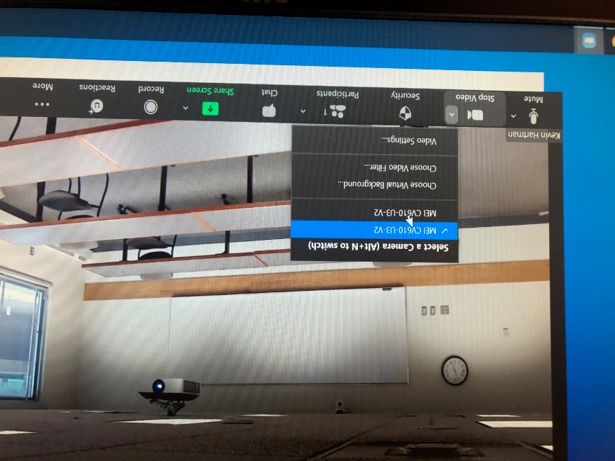

The microphones themselves are in the ceiling: The instructor mic is near the projected image and podium, the audience mic is in the ceiling near the projector.
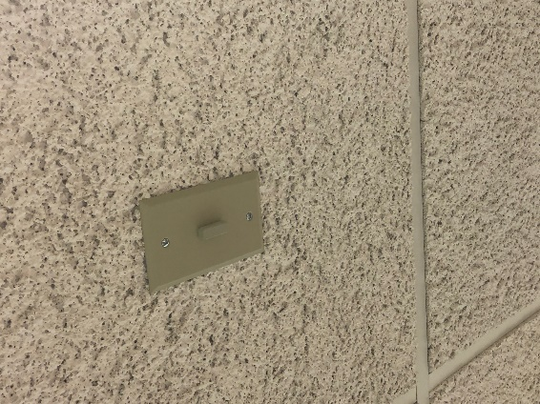

NOTE: The microphones are integrated into the camera. You cannot select the Audience Mic and Instructor Camera, or vice versa. If you want to use a personal USB webcam and microphone, please contact SOM-IT.

- If you ever need to play a video clip or an audio file from the PC, click the Share Screen button, and then check “Share Computer Sound” and “Optimize Screen Sharing for Video Clip” in the lower left. Hit Share.
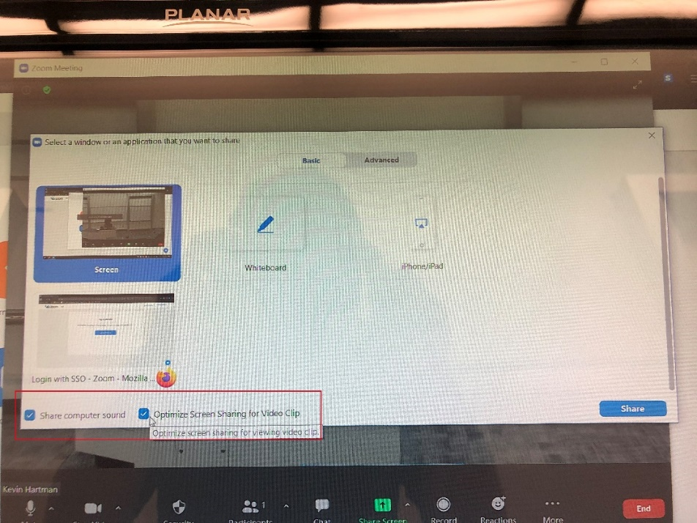

- When your meeting is over, end the Zoom meeting, and sign out and close out of Zoom and other services you opened (UB Learns, UB Box, etc.) Sign out of the computer.

Turn off the projector by hitting the green “Standby” button on the remote control. Turn off the camera(s) by walking up to them with the camera remote and pressing the power button in the upper left.
