Using Webcam for Zoom in Jacobs B34

- Open the Zoom app on the teaching station PC, and select “Sign in with SSO” on the right hand side.
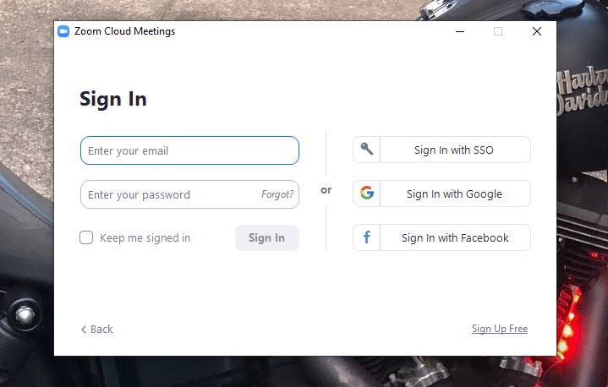
- Enter ‘buffalo’ as the domain and click continue.
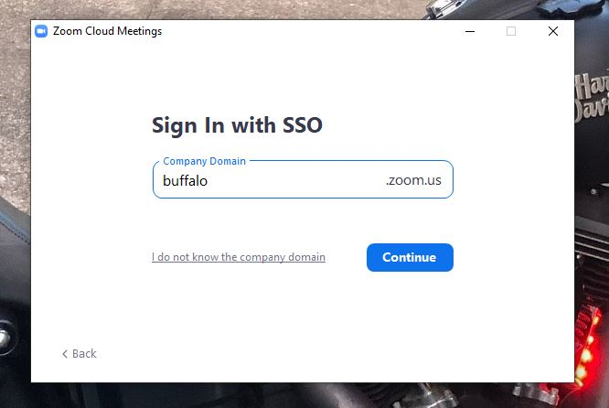

- You will be taken to the UB sign on screen, login with your UBIT name and password.
NOTE: BE SURE TO LOGOUT AT THE END OF YOUR CLASS

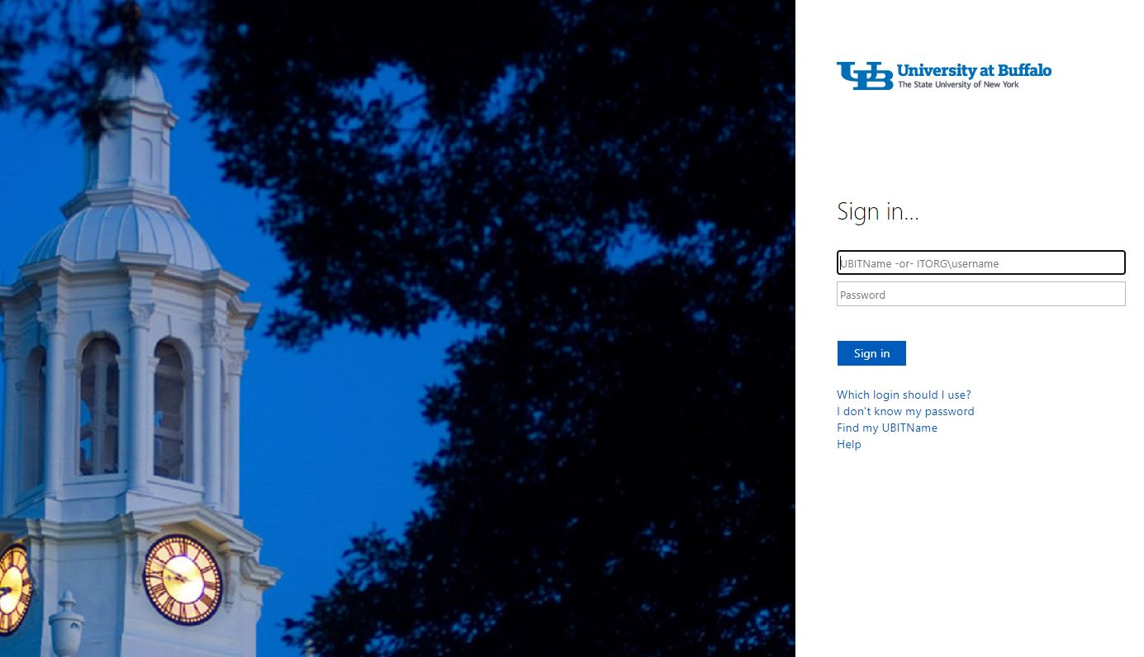

- A Zoom page will open, and a box will appear with an option to open Zoom. That will open the desktop app.
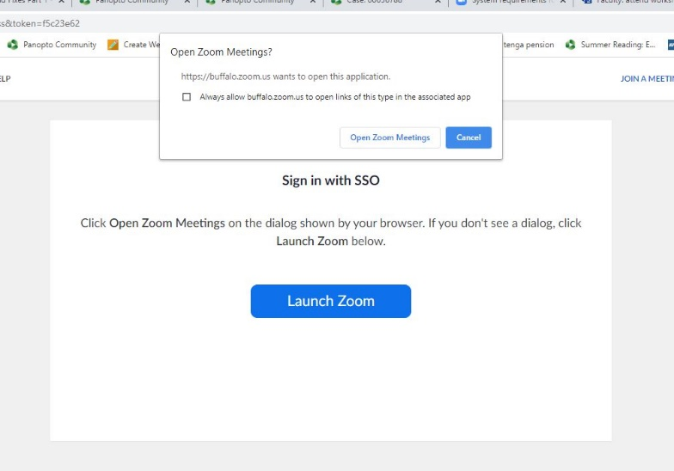

- Start your meeting, either from the Zoom web portal (buffalo.zoom.us), the desktop app, or UB Learns if using the Zoom integration.

- Select your video and audio, and choose the speaker source to hear students on the far end.

The microphone and speaker are both under the Audio button, the Camera is listed under the video button.

For Microphone select “Microphone (USB Audio Device)”. If you’re bringing a personal USB microphone that you want to use, select that device.

For Camera, select USB Video Device.
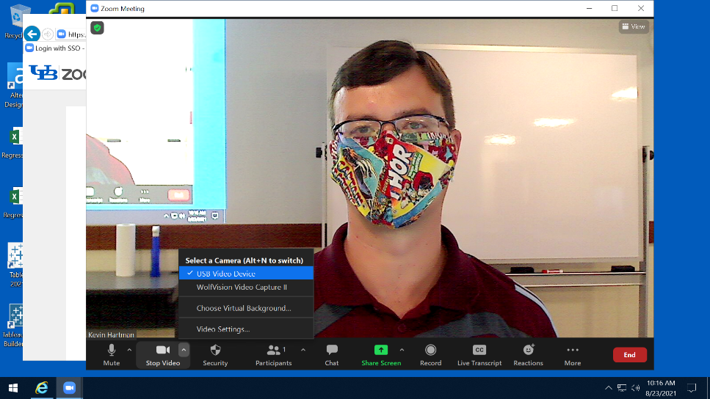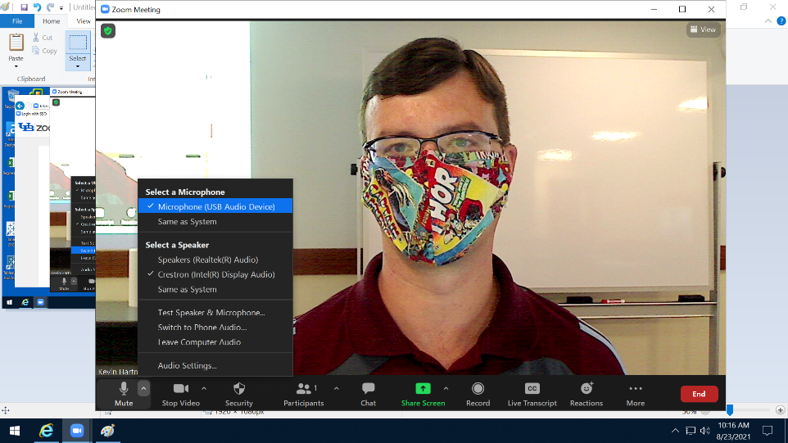

For speaker select Crestron (Intel Display Audio) in B30/B34, or Extron HDMI (Intel Display Audio) in B32.

- The document camera is available as a source to share in Zoom as well. To select the doc cam, press the Screen Share button, select Advanced at the top, then press the button for “Content from 2nd Camera, and hit “Share”.

NOTE: PLEASE POWER ON AND SETUP THE DOCUMENT CAMERA BEFORE YOUR CLASS STARTS TO MAKE SURE IT’S SETUP PROPERLY
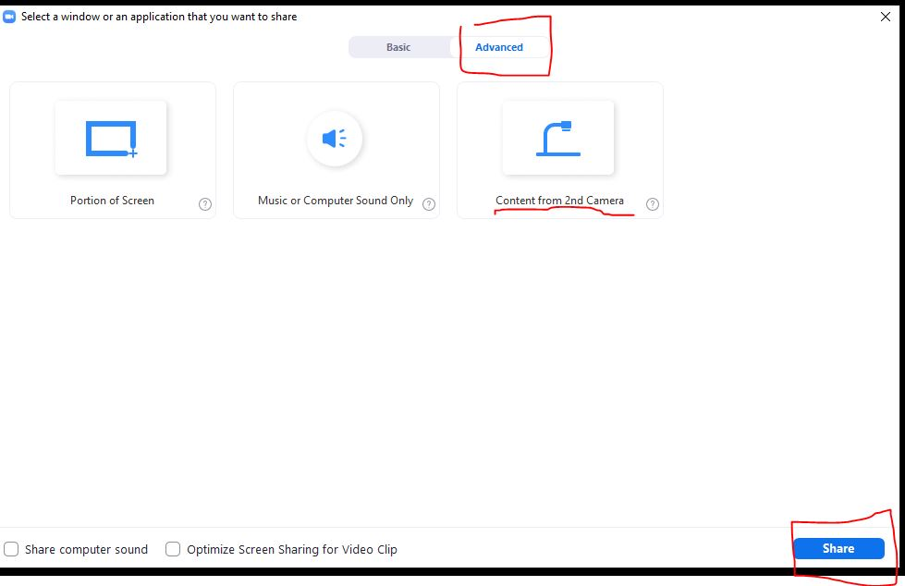

- If you ever need to play a video clip or an audio file from the PC, click the Share Screen button, and then check “Share Computer Sound” and “Optimize Screen Sharing for Video Clip” in the lower left. Hit Share.
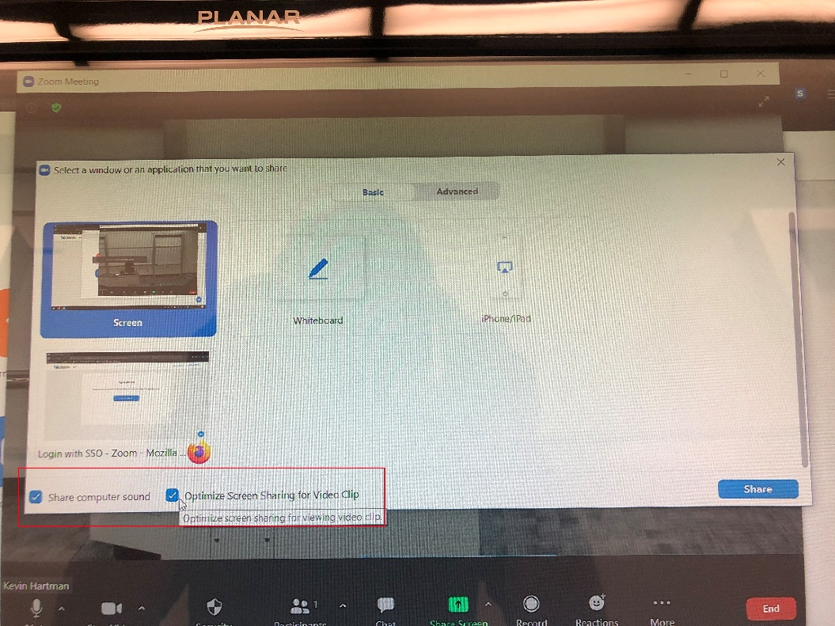

- When your class is over, end the Zoom meeting, and sign out and close out of Zoom and other services you opened (UB Learns, UB Box, etc.)

