Using Zoom in Jacobs 106
- Make sure the podium gooseneck microphone is unmuted. To do so, press the green Room Controls button in the lower right of the touch screen.
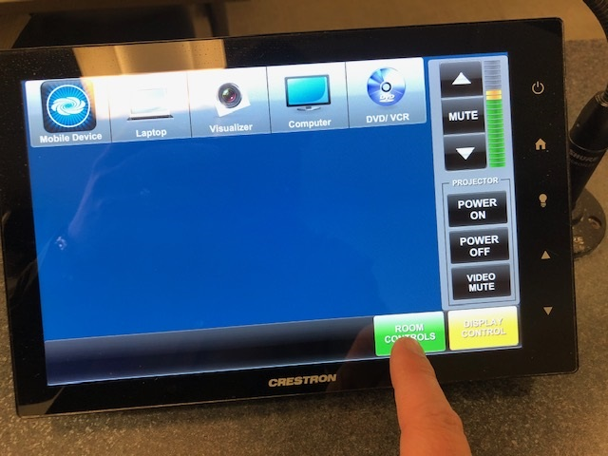

- Podium Mic: when shaded light blue, the microphone is muted, meaning it is not picking up your voice and your voice is not being recorded.
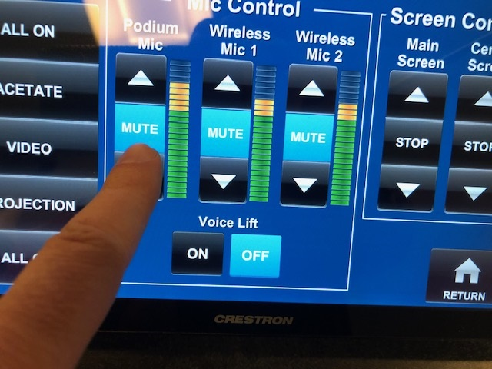

- To um-mute the Podium Mic, Press the Mute button for it. The button will turn to a dark blue. The mic is now picking up sound, and your voice will be recorded.
Please project your voice and talk loud enough that if someone was sitting in the back row, they could hear you clearly. You can raise and lower the mic volume by hitting the up and down arrows if needed.
Voice Lift: select “ON” if microphone reinforcement from ceiling speakers is required for in-class students.
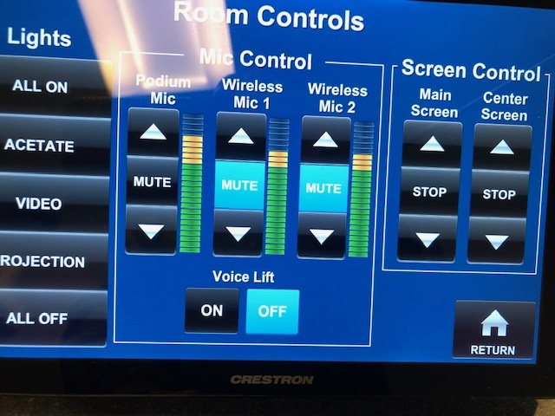

- Open the Zoom app on the teaching station PC, and select “Sign in with SSO” on the right hand side.
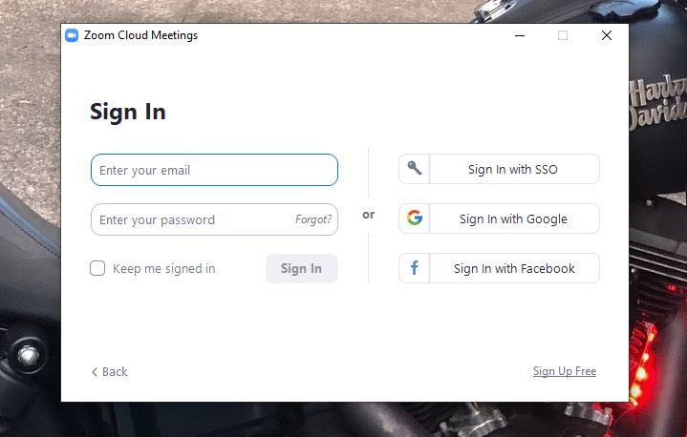

- Enter ‘buffalo’ as the domain and click continue.
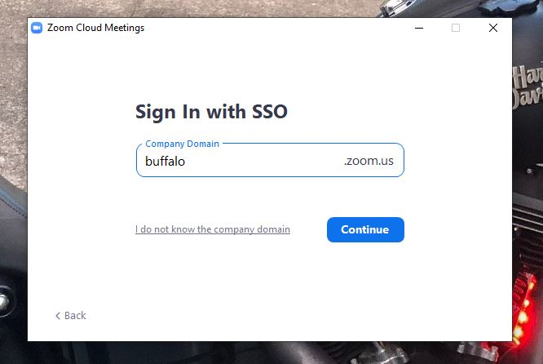

- You will be taken to the UB sign on screen, login with your UBIT name and password.

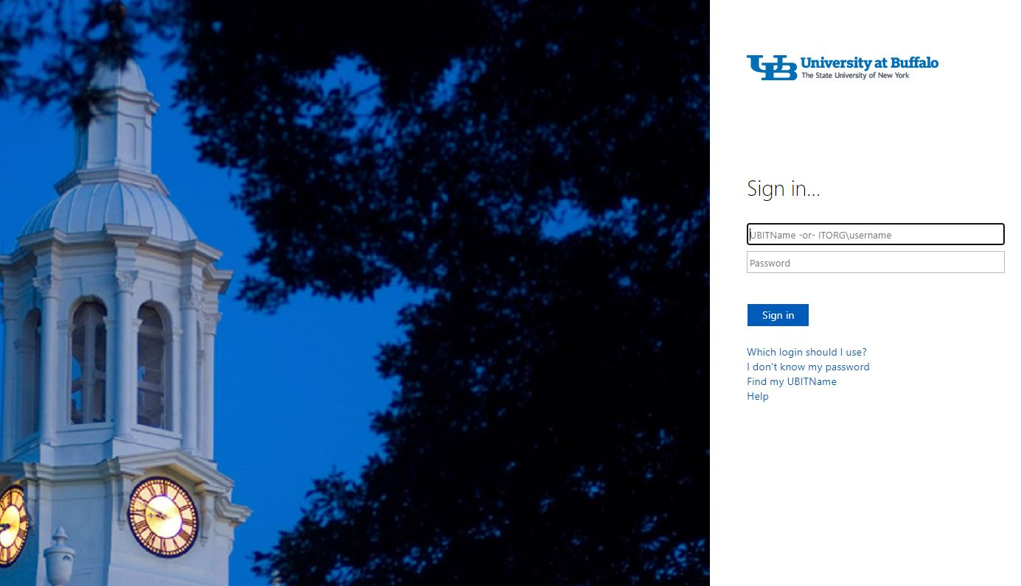

- A Zoom page will open, and a box will appear with an option to open Zoom. That will open the desktop app.
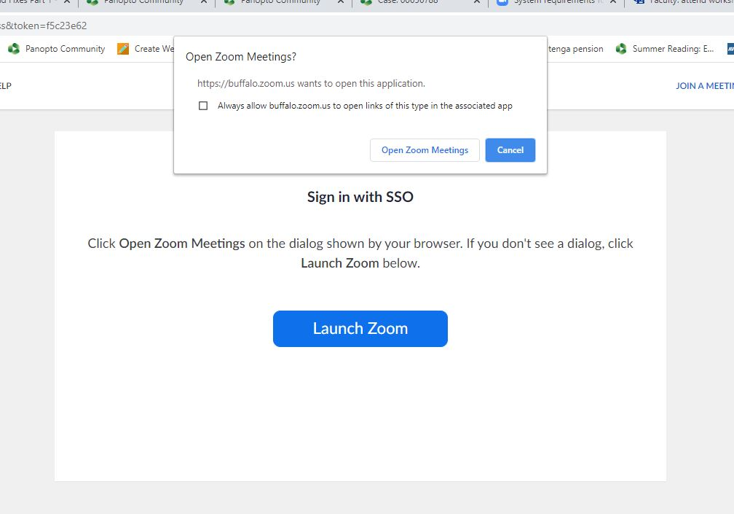

- Start your meeting, either from the Zoom web portal (buffalo.zoom.us), the desktop app, or UB Learns if using the Zoom integration.

- Select your video and audio, and choose the speaker source to hear students on the far end. The sources needed for each classroom are listed below.

Microphone and Speaker are both under the Audio button, the Camera is listed under the video button.

For Microphone and Camera, select AV Bridge, for speaker select Realtek (R) Audio

- If you ever need to play a video clip or an audio file from the PC, click the Share Screen button, and then check “Share Computer Sound” and “Optimize Screen Sharing for Video Clip” in the lower left. Hit Share.

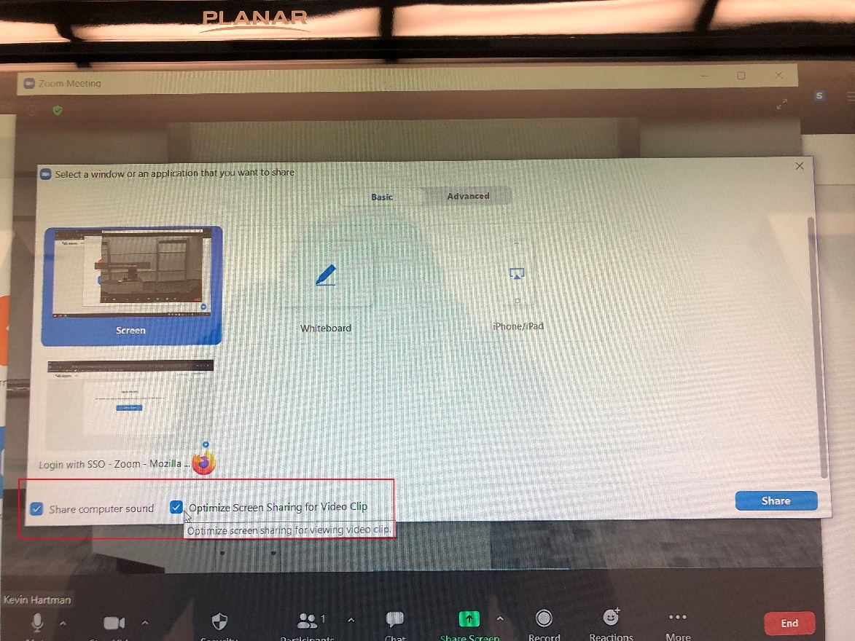

11. When your class is over, end the Zoom meeting, and sign out and close out of Zoom and other services you opened (UB Learns, UB Box, etc.)

